Hampton Hill Cricket Club
COVID 19 Bar Opening Procedures
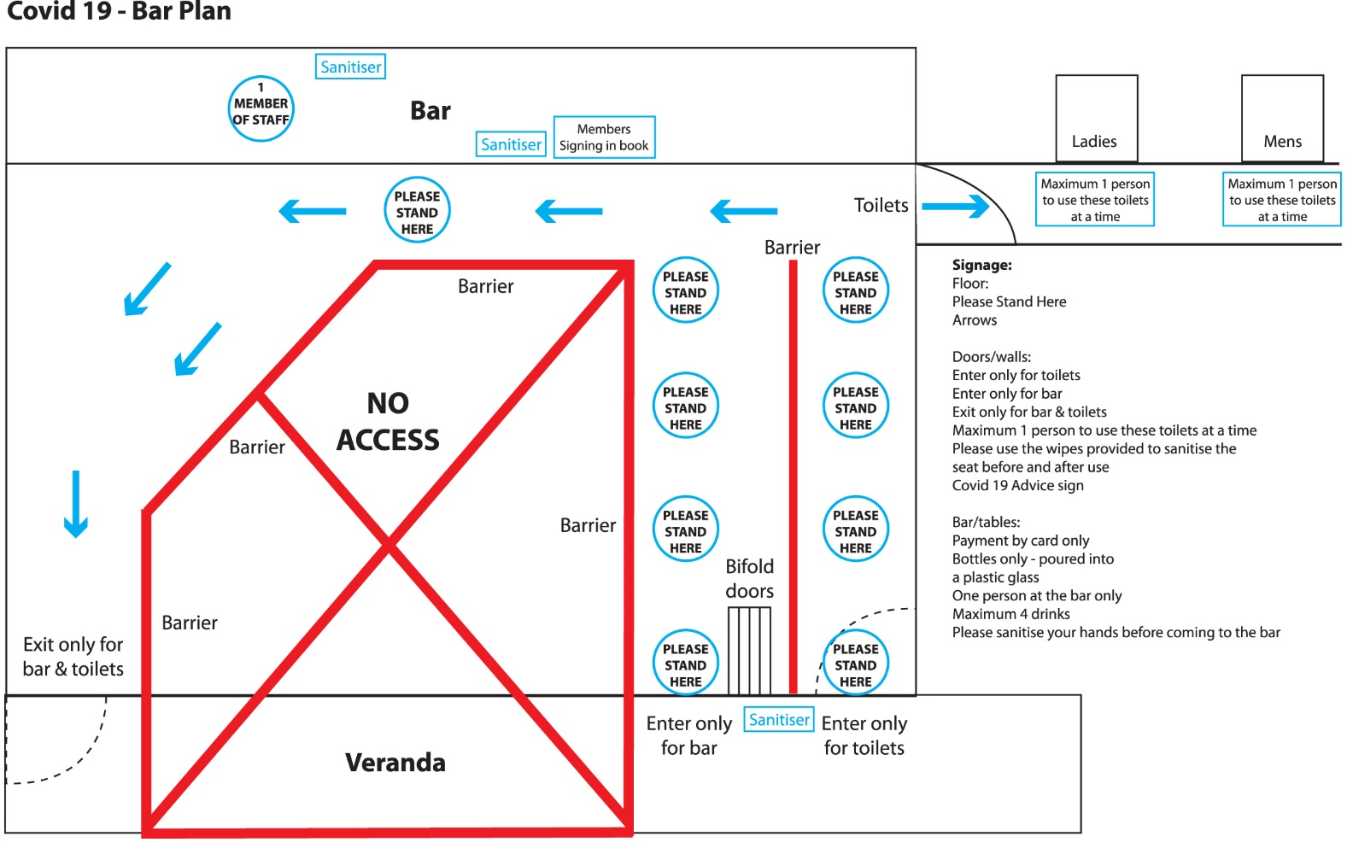
Communication on bar opening
- All members informed by email when the bar will be opening, including bar opening days/times and the social distancing procedures that have been put in place.
- All bar staff to be sent written list of procedures before starting work.

Before opening
- Bar and toilet area cleaned and sanitised.
- Tables and chairs for outside use cleaned and positioned within distancing guidelines.
- Ensure bins are provided outside and inside.
- Bar staff fully briefed on all procedures. Laminated list of procedures for bar staff to refer to provided.
- Ensure all signage and information is correctly positioned.
- Only one member of staff serving behind the bar.
- Bar staff given the option to wear a mask and/or gloves. Gloves can be provided by HHCC.

During opening
- Strict social distancing guidelines and dedicated entrance and exit routes for members when entering and exiting the Pavillion either for the bar or toilets, using clear signage on the floor and on tables/walls. See plan above.
- Hand sanitiser stations provided for members on entering the Pavilion, and at the bar. Hand sanitiser provided for bar staff, behind the bar.
- Signing in book for members, positioned on the bar. Members must sign in with their name and email address. Bar staff to ensure they ask every customer to do this before serving.
- Only one person to be served at the bar at any time.
- Drinks to be served in plastic glasses at all times. No glass bottles to be taken outside, including full bottles of wine.
- Maximum of 4 drinks ordered at a time.
- Members must be able to carry their order in one go. They cannot take part of their order and return for the rest.
- NO cash transactions, card payments only. Contactless where possible.
- Strictly NO tabs behind the bar.
- Bins provided outside for plastic cups.
- Bar staff to sanitise the bar surface, and wipe down the till and card machine with anti-bac wipes between every serving.
- Bar staff to use hand sanitiser after serving every customer.
- Tables and chairs cleaned regularly during opening.
- Committee member to ensure outfield is clear of rubbish at regular intervals, and is disposed of in our bins.
- Maximum 1 person to enter the toilets at a time. Clear signage stating this is on the doors of both Ladies and Men's toilets.
- Signage to inform anti-bac wipes available for use in toilets before and after every visit. Soap for hand washing and hand dryers available for use.
- Committee member to check toilets and sanitise every hour.
- A committee member to regularly oversee social distancing guidelines are being followed inside and outside the pavilion by our members.

Closing the bar
- Committee member to gauge the amount of people inside the pavilion that can be served before closing time.
- Toilets will be closed at the same time as the bar to allow for cleaning.
- Staff/committee member to ensure the Pavilion is clear of members before proceeding to shut down.
- Bar staff to sanitise the bar, wipe down the till and card machine with anti-bac wipes.
- Ensure rubbish is cleared from outfield and disposed of in our bins.
- All bins to be emptied and placed in our wheelie bins.
- Put away any free-standing signage and signing in book ready for next opening.
- Bar staff to ensure the whole bar area is clean and tidy before next opening.
- Committee member to oversee closing.
- Committee member to lock up.
- Bar staff to be paid online.

